Standard Operating Procedure (SOP)
Title: Implement Shipley Brews Menu to a Store (NCR) and OLO
Purpose: Assign all Shipley Brews menu items to the selected store.

Step 1: Select the Store
Open NCR Back Office and select the target store where Shipley Brews will be implemented.

Step 2: Open Categories & Items
Navigate to Menu → Categories & Items.
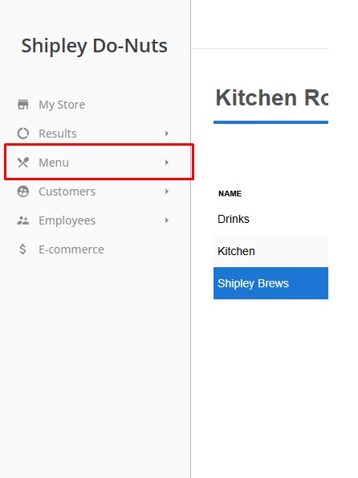

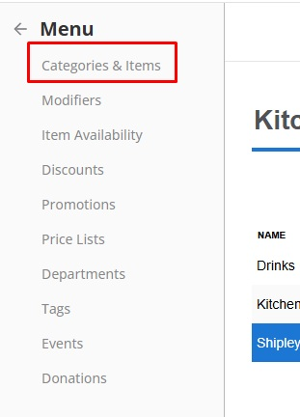
Figure 2

Step 3: Open Edit Multiple Items
Scroll down and click Edit Multiple Items.
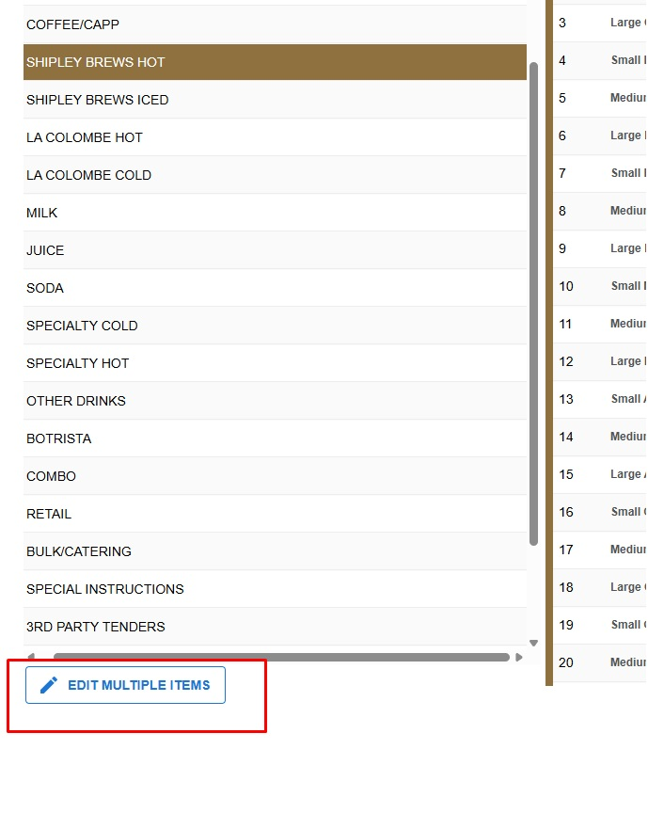
Figure 3

Step 4: Select Shipley Brews Hot
From the category drop-down list, select Shipley Brews Hot.
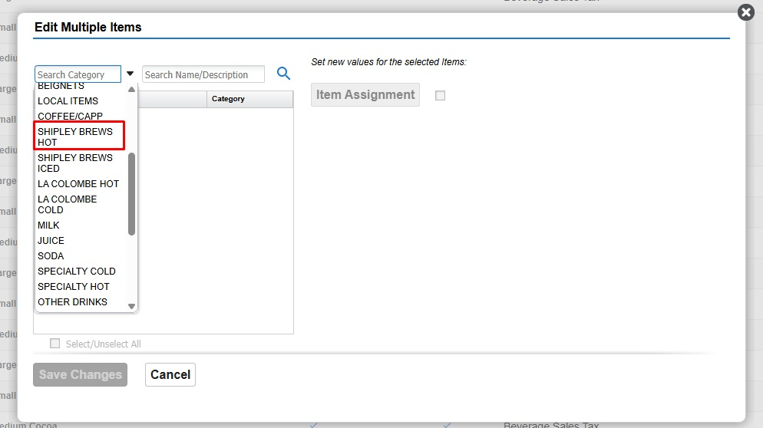
Figure 4

Step 5: Assign Items
Click Item Assignment.
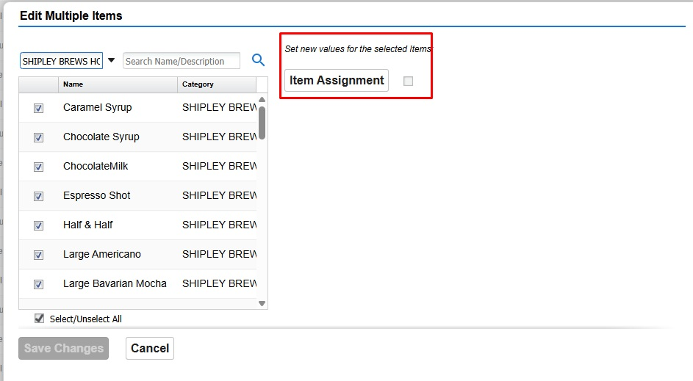
Figure 5

Step 6: Assign All Items
Select Select/Unselect All, verify all items are assigned, then click Done.
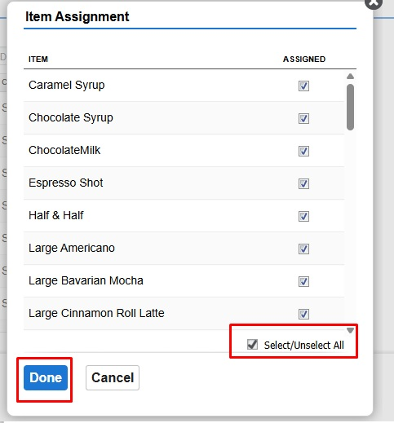
Figure 6

Step 7: Repeat for Shipley Brews Iced
Repeat Steps 3 through 6, but select the Shipley Brews Iced category instead of Shipley Brews Hot.

Step 8: Adding Shipley Brews in Olo
Once you are logged in Olo go to menu > Manage Menus >Manage Stores
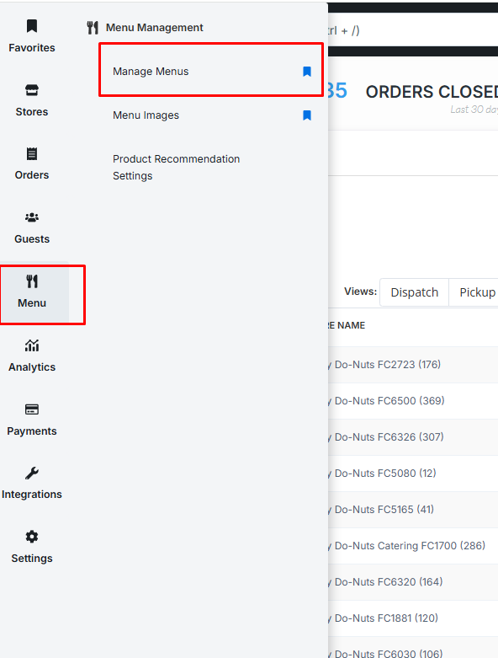
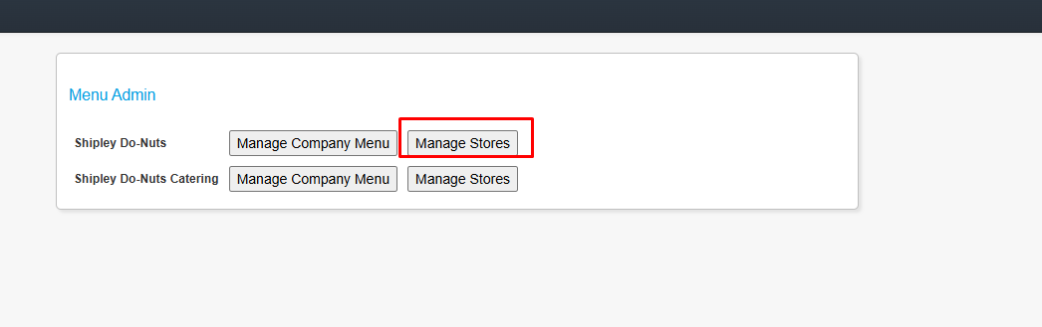

Step 9: Select Store
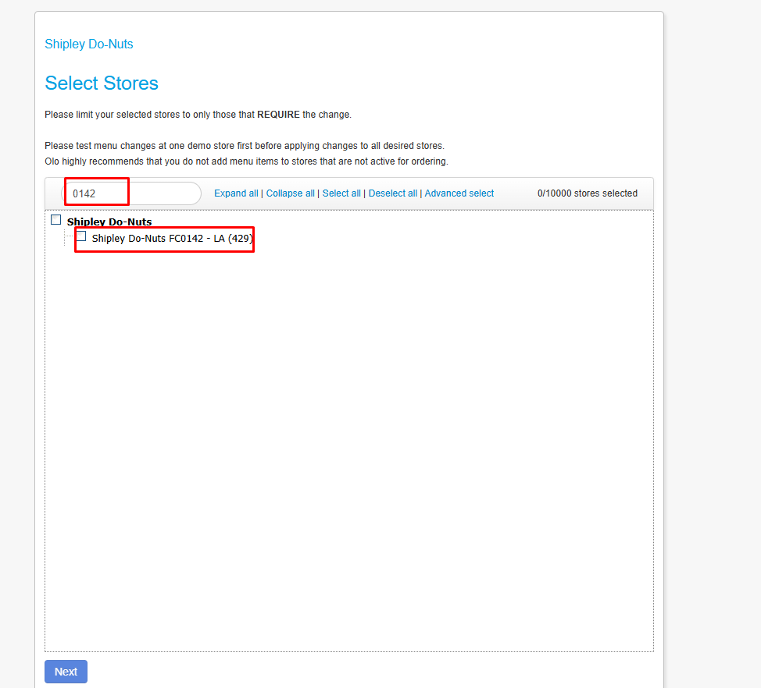

Step 10: Add Categories
Look for Shipley Brews (Hot) and Shipley Brews (Iced) should be at the top and click on add category
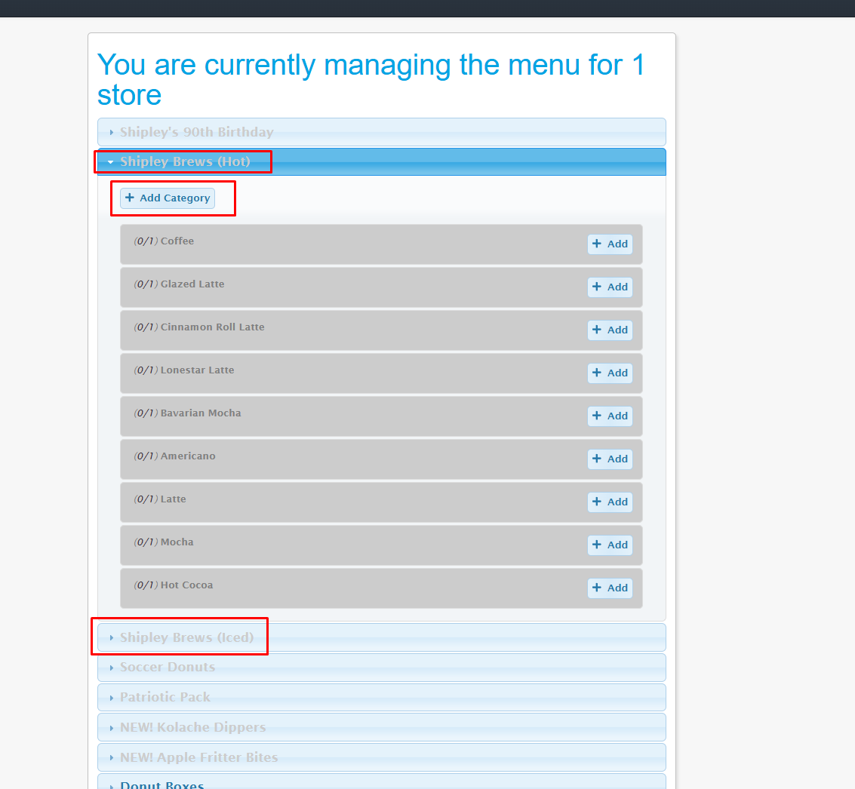
Add Sync pricing with NCR,
Also ask when is plan to go live date. And 86d until that date.

